KWBY Sailfish Spirit Wear 2014-2015

ITEM 1: Short-sleeved tee shirt - Ultra Cotton:
Size options are:
YS | YM | YL | Adult S | Adult M | Adult L | Adult XL**
**Add $2.00 each for XL***
Please indicate color choice and sizes:
Irish green w/ white lettering Style 1 only |  | Blue w /white lettering Style 2
Quantity and size |  | Quantity and Size
Price/each: $15.00 (** $17/each for XL) Total shirts: _________ Total cost:
ITEM 2: Hoodie sweatshirt options are Ultra Cotton:
YS | YM | YL | Adult S | Adult M | Adult L | Adult XL**
Please indicate color choice and sizes:
Irish green w/ white lettering Style 1 only |  | Blue w /white lettering Style 2
Quantity and size |  | Quantity and Size
Price/each: $25.00 (**$27/each for XL) Total sweatshirts: _________ Total cost:
ITEM 3: Gildan Stadium blanket in Irish green w/ Sailfish design in white in the corner:
Price/each: $18.00
Total blankets: _________ Total cost: __________
Please contact Shelley Tuter if you have any questions on the
Sailfish Spiritwear: kwbysailfishspiritwear@gmail.com
Order forms and payment due by December 1, 2014 NOON. Orders will be submitted on the Dec 1 in order to get them by Dec 17th. You can give form and payment to Shelley Tuter or place in swimteam mail or file box.
Make checks payable to YMCA --Memo Sailfish Spirit Wear
===SPIRIT WEAR TOTAL COST:_______________
Point of contact: _____________________ CASH/CHECK #____________________
Phone Number: _____________________ Email: ___________________________
Style 1 – Irish Green Official 2014 Swim Team Shirt
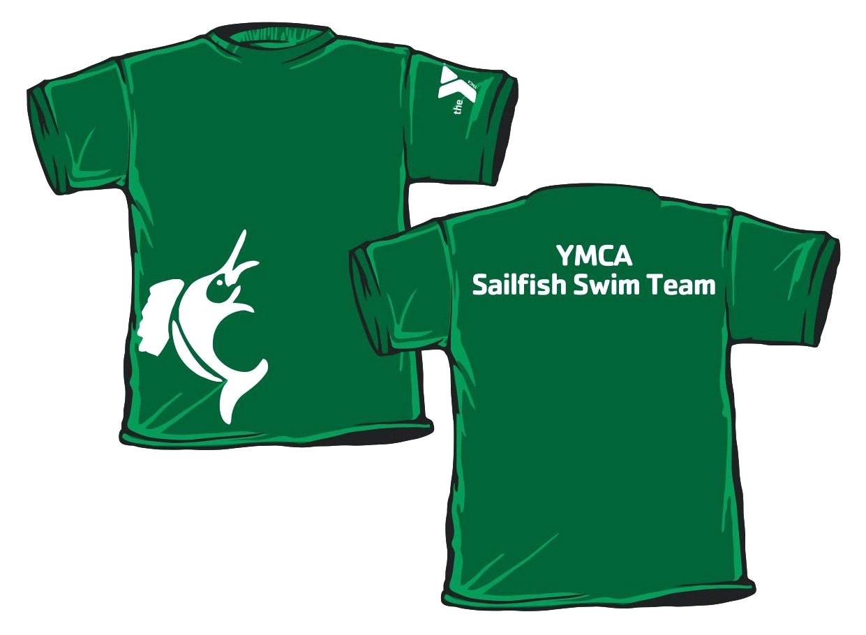Style 2 – Alternate Swim Team Shirt Blue * North Carolina
Blue*
(not offered in Irish Green)
